FOREACH LOOP CONTAINER
(Foreach File Enumerator option)

Presented at
Houston SQL Server User Group
November 8, 2011


Michael D. Newby
Recursive Creativity LLC
SYNOPSIS
This presentation and accompanying material was designed to provide a mechanism to learn how to use the Foreach Loop Container to load a series of .CSV (comma delimited) files into a SQL Server database using SQL Server Integrated Services (SSIS). The SSIS package was created using SQL Server 2008 BIDS.
The Foreach Loop Container has numerous options. The option this presentation will cover is the Foreach File Enumerator option. In short, this option provides a mechanism for you to point to a directory and automatically load all file(s) types in that directory, including any files in other folders (subdirectories) within that folder, into a designated SQL Server database table.
Files that should be included in the compressed file for this presentation:
- This Word Document, which provides a step by step approach to create the solution created during the presentation.
- A compressed file of the SQL Server Integrated Services (SSIS) project created using SQL Server Business Intelligence Development Studio (BIDS).
The BillingData and Stock Market (Prices and Dividends) projects will be made available.
- A compressed file of SQL Server queries that create objects within SQL Server that are utilized by the SSIS package.
- A compressed file that contains the .CSV files for both aforementioned projects.

Table of Contents

Synopsis 2
Getting Started 5
Prerequisites 5
SSIS Package Overview 8
Configuration of Objects 10
Connection Managers 10
Flat File Connection 10
OLE DB Connection 16
Control Flow 17
Execute SQL Task 17
Execute SQL Task 1 17
Foreach Loop Container 18
Adding a Variable 18
Container Properties 20
Collection 21
Variable Mappings 23
Table of Contents
(continued)

Configuration of Objects (continued)
Data Flow 24
Flat File Source 24
Connection Manager 25
Columns 25
OLE DB Destination 26
Connection Manager 26
Mappings 27
Flat File Connection Variable Assignment 28
Additional Resources 34
Getting Started
As stated earlier, the SQL Server Integrated Services (SSIS) package was created using SQL Server 2008 Business Intelligence Studio (BIDS).

Prerequisites
Prerequisites for you to recreate a working package with the material provided are:
- A working version of SQL Server 2008 Database Engine with all applicable Service Packs and Microsoft Updates applied.
I have also installed many of the tools in the SQL Server 2008 SP2 Feature Pack.
I also use the SQL Server 2008 Developer Edition. It is available for around $50 US from many different retailers. It is the SQL Server 2008 Enterprise Edition that can be installed on as many computers you are the primary user of. I have a laptop and 3 desktops it is installed on.
The computers can be at work or at home. The two caveats are (1) make sure you have local Admin rights on your computer at work before attempting an install and you are not violating any company policies by installing “personal” software, and (2) the Developer Edition cannot be used in a commercial, production or retail environment, it is strictly for development and testing.
- You must create a database for each project: BillingData (no spaces) and Stocks. If you choose to rename your database, please note that any future reference to BillingData or Stocks should be replaced with whatever you name your database.
- You must run the SQL scripts to create the Service table in the BillingData database.
Running this script will eliminate having to make other changes to the SSIS package associated with this exercise.
The Advanced properties in the Flat File Connection are set to match the properties of each column in the table created using the script.
If you create a database named something different from BillingData, the script needs to be changed to reflect the name of the database you created.
I have also included the .CSV file that contains the Billing data included with the project in case you want to take a closer look at the Excel file accompanying my previous presentation on this data.
- The .CSV files for the BillingData project must be extracted from the compressed file.
The objects included with the SSIS package associated with this presentation and discussed below are in the path:
C:\Sample Data\Billing\Monthly Billing Files\
In the path above are the monthly files. I have also included the .CSV file that contains all the monthly data in one file.
- The SSIS package must be extracted from the compressed file.
Most SSIS packages are located in the following path:

Windows Vista and 7:
C:\Users\__YOUR USER NAME__\Documents\Visual Studio 2008\Projects
Windows XP:
C:\Documents and Settings\__YOUR USER NAME__\My Documents\Visual Studio 2008\Projects

I backup or “synchronize” my “Documents” folder to an external drive so I recommend placing them in your “Documents” (Vista or Windows 7; My Documents if you have Windows XP).
More about the logic behind “synchronization” can be found on page 91 in the PC Configuration Tips document I have posted on the home page of my website.
However, if you keep your projects in the “SSIS Store” for SQL Agent, you will need to place them in the default location or whatever path you changed your “store” to.
SQL Server Integrated Services (SSIS) Package Overview
Below is an overview of the BillingData package that is contained in a compressed file associated with this presentation.
The errors indicated by the red circles with X’s will go away as properties of the objects are changed as part of the steps below.
You will need to create the objects shown below.
The Control Flow tab:
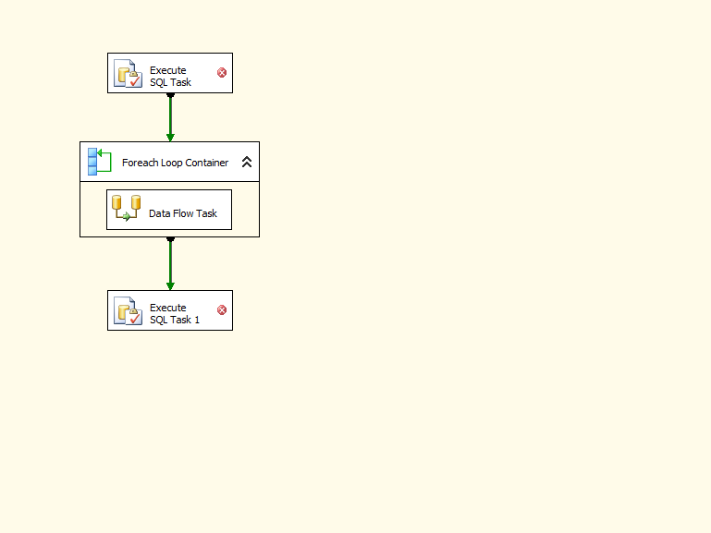The Execute SQL Task object truncates the Service table in the BillingData database. By default, the Execute SQL Task, “Truncate Service Table”, will already be set up in the project contained in the compressed file associated with this presentation.
The Data Flow tab associated with the “Data Flow Task” object in the Control Flow tab:
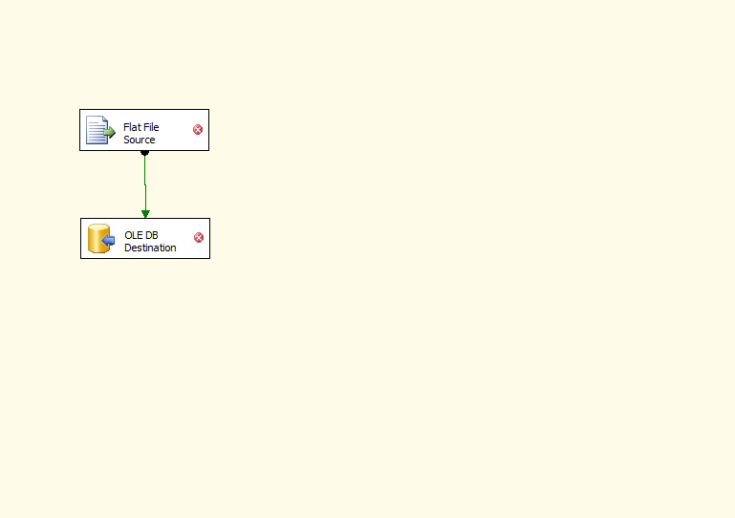
Each of these will be configured as part of the Data Flow Configuration steps below.

The Connection Managers associated with this project are:
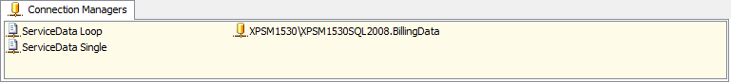
Certain aspects of these objects will need to change because my environment will have different parameters than yours. Changes are discussed below in the Connection Managers Configuration section.
Configuration of Objects
Connection Managers
This section assumes you have created the objects shown in the Connection Managers window above.

Flat File Connection
To create and configure the Flat File Connection as shown above:
- Right-click in the Connection Managers window and select New Flat File Connection, you will see the following window and below are some changes to be made.
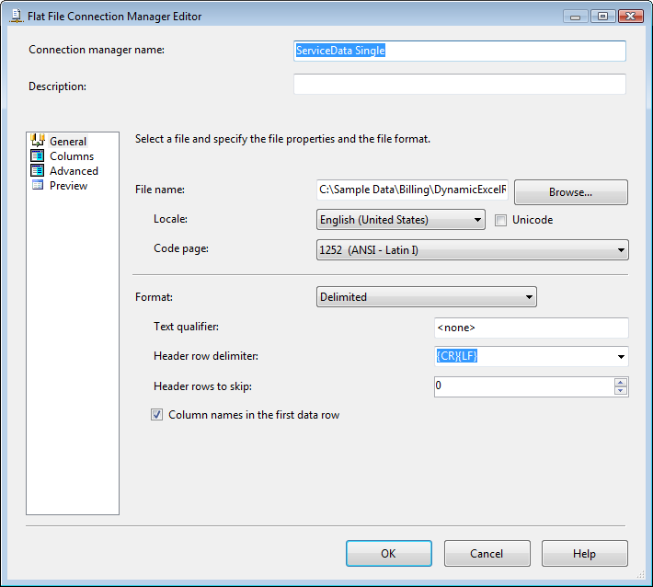
- Connection manager name:
- ServiceData Single
- ServiceData Loop
- The complete entry in File Name above is:
- ServiceData Single
C:\Sample Data\Billing\DynamicExcelReporting-ServiceData.csv
- ServiceData Loop
C:\Sample Data\Billing\Monthly Billing Files\Services-200801.csv
When you first set up the configuration of this object you will actually choose a file so that the Columns and Advanced properties can be selected and changed.
Please note also that after clicking on the Browse button you need to change the default file type from “ Text files (*.txt)” to “CSV files (*.csv)” for the files provided to appear for selection.
- Please note the check mark for “Column name in the first data row”.
- Details of Columns properties are:
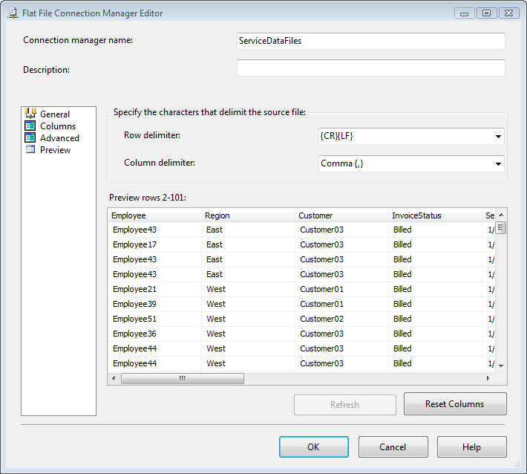
After you have entered or changed data in the Advanced properties discussed below, do not click on Reset Columns unless you see something different than shown above. If you click Reset Columns, any settings in the Advanced properties window will need to be reentered.
- Advanced properties need to be edited for each field or column listed:
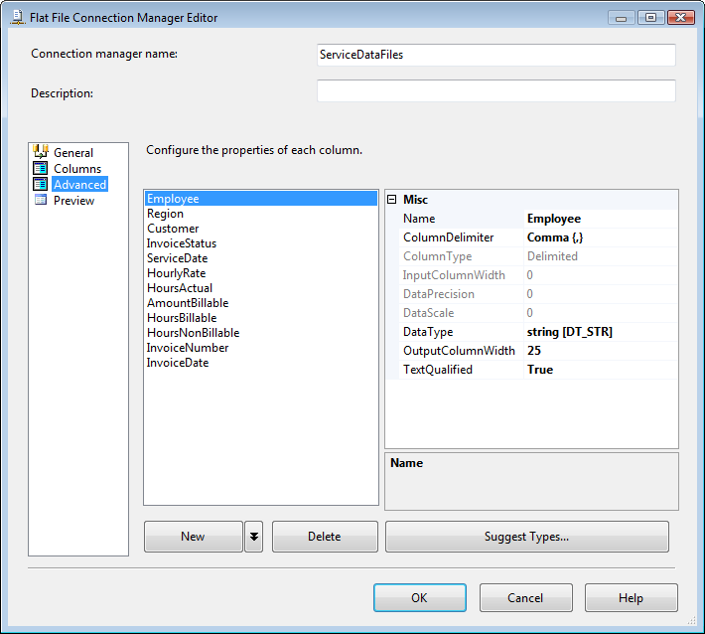
Please note the DataType for each column in the data file chosen…..the settings for each column will need to be changed to match the corresponding Data Type in the SQL Server database, BillingData.
A good resource for showing how SQL Server data types map to SSIS or vice versa is found on Siddarth Mehta’s blog.
If you clicked on the Reset Columns button in the Columns properties window, you will need to reenter any changes you make to the Advanced properties. I make the changes here to avoid having to use the Data Conversion object under Data Flow.
Advanced properties for all fields (columns):
Employee | varchar | 25
Region | varchar | 15
Customer | varchar | 25
InvoiceStatus | varchar | 25
ServiceDate | datetime
HourlyRate | money
HoursActual | decimal | 18 | 2
AmountBillable | money
HoursBillable | decimal | 18 | 2
HoursNonBillable | decimal | 18 | 2
InvoiceNumber | bigint
InvoiceDate | datetime

It is easier if you set up the first Flat File Connection and make a copy of it, rename it, and then change the File Name (change path and file selection). This will keep you from having to reenter the Advanced properties.
OLE DB Connection
Your properties for this object most likely need to be changed.
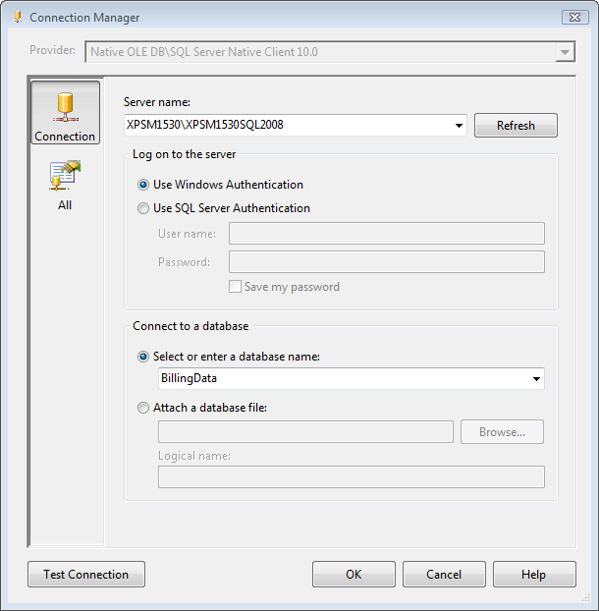
From the drop-down menu you will select whatever computername\sqlserverinstance you installed and created the BillingData database on. If you did not name your database, BillingData, change the above reference to whatever you named it.

Control Flow
This section assumes you have created the objects shown on the Control Flow tab above.

Execute SQL Task
For each of the Execute SQL Task objects, the only changes will be to the Connection property and the SQLStatementSource properties.
- Connection property
You will need to change it to whatever you named your OLE DB Connection in Connection Managers.
Please note that these changes could also be made from the Properties window, if shown. However, it is a manual process to type the properties or cut and paste them.
- In the SqlStatementSource property, add: (without quotes)
“TRUNCATE TABLE Service”.
The Service table is created in the BillingData database with a script available with downloads for this presentation.
Execute SQL Task 1
- Connection property
You will need to change it to whatever you named your OLE DB Connection in Connection Managers.
- In the SqlStatementSource property, add: (without quotes)
“dbcc shrinkdatabase(BillingData, 10)”.
Foreach Loop Container
Adding a Variable
Before configuring, changing or setting any properties on the Foreach Loop Container, you should first create a variable.
There are several ways to do this but I do it by:
- Opening the Variables window:
  - Right-click anywhere in the open space of the Control Flow window and choose Variables,
  - Using the menu, choose View, Other Windows, Variables (the Control Flow window must be the active window for the Variables option to appear under Other Windows).
- Click on the Add Variable button (far left) in the Variables window Toolbar
- Edit the Variable properties.
You can edit some of the properties in the Variables window but I prefer editing the variable properties from the Properties window:
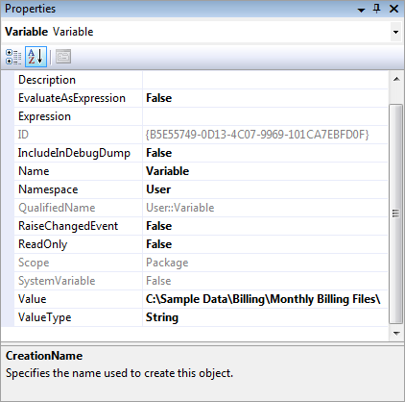
- Change the Name from Variable to whatever you prefer,
- Change the Value from 0 to the path of the .CSV files to be loaded.
The sample .CSV files associated with this presentation are located in:
C:\Sample Data\Billing\Monthly Billing Files\
Do not forget to end the path with “\”.
- Change the ValueType from Int32 to String.
Please note that the variable above must be created
Editing the properties of the Foreach Loop Container
Double-click the Foreach Loop Container to open the Foreach Loop Editor. You should see the following window:
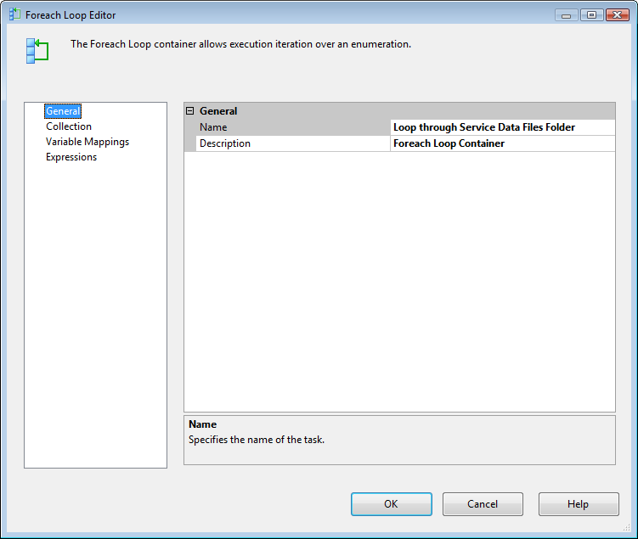
Some texts and websites overlook an important aspect of this window….what I consider a bug in SSIS.
Collection Properties
Click on Collection and you will see the following window:
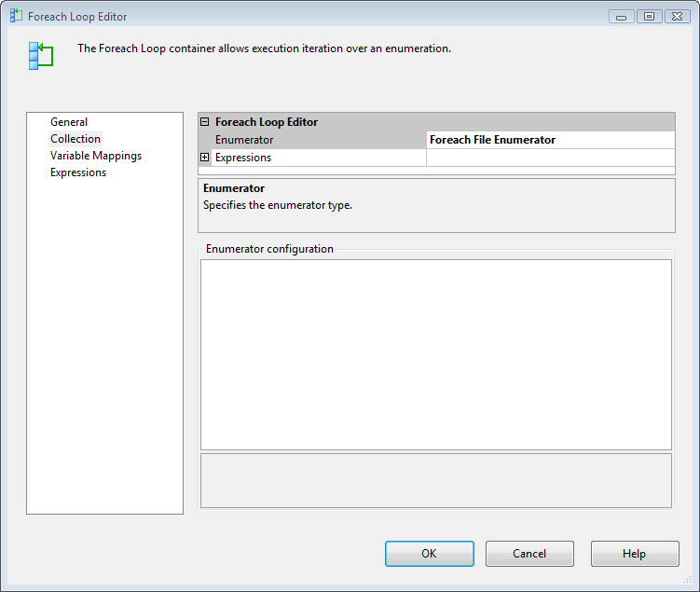
Please note there are no properties shown for the Foreach File Enumerator option.
To get to the properties you have to change the selection shown in the Enumerator field and then change it back to Foreach File Enumerator.
Once you do this you will see the following window:
(except I have already made changes listed below)
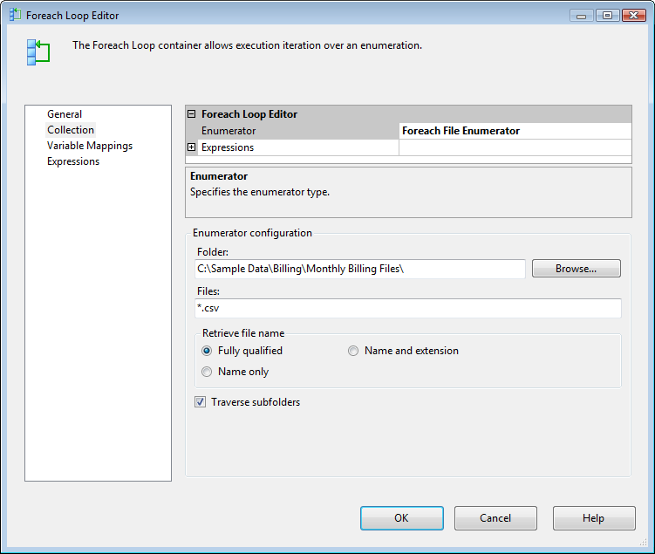
Make the following changes to this window:
- Change the folder path to:
C:\Sample Data\Billing\Monthly Billing Files\
- Change Files to *.csv
Your processes may dictate that you need to check the Traverse subfolders option.
Variable Mappings Properties
Click on the Variable Mappings option and you will see the following window:
(except I have already made changes listed below)
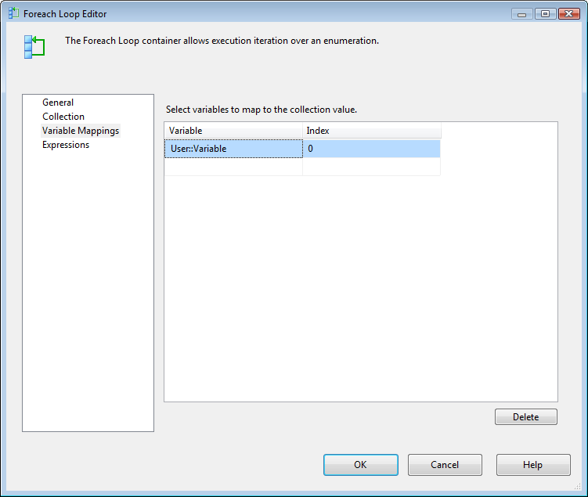
Click on the Variable field and from the drop-down menu select User::Variable. Whatever is listed here is most likely reflects the variable name you entered in previous steps.
Click OK to close the Foreach Loop Editor window.

Data Flow Configuration
This section assumes you have created the objects shown on the Data Flow tab above.

Flat File Source
Double-clicking on the object will open the Flat File Source Editor window which already has the properties changed as discussed below:
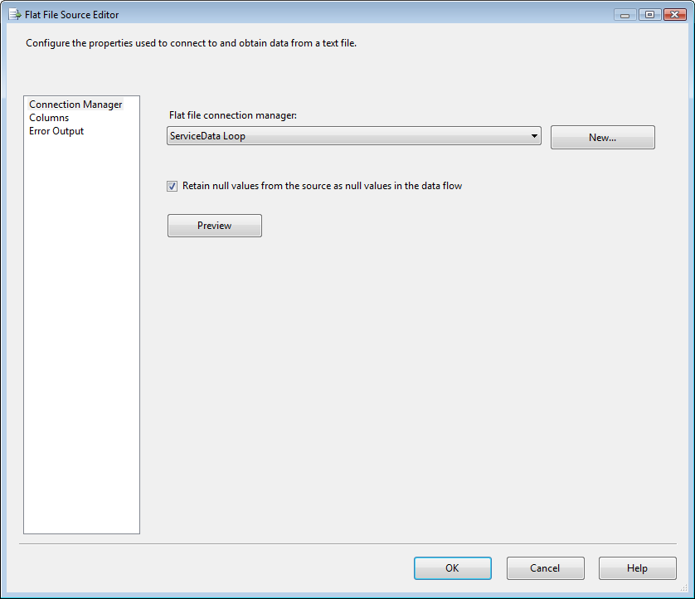
Connection Manager
- Change the Flat file connection manager: to ServiceData Loop or whatever you named it in the above steps.
- Click on Retain null values from the source……
Columns
Choosing columns in the Flat File Source Editor is used to ensure you selected the correct file and the columns you expect to load are shown and checked.
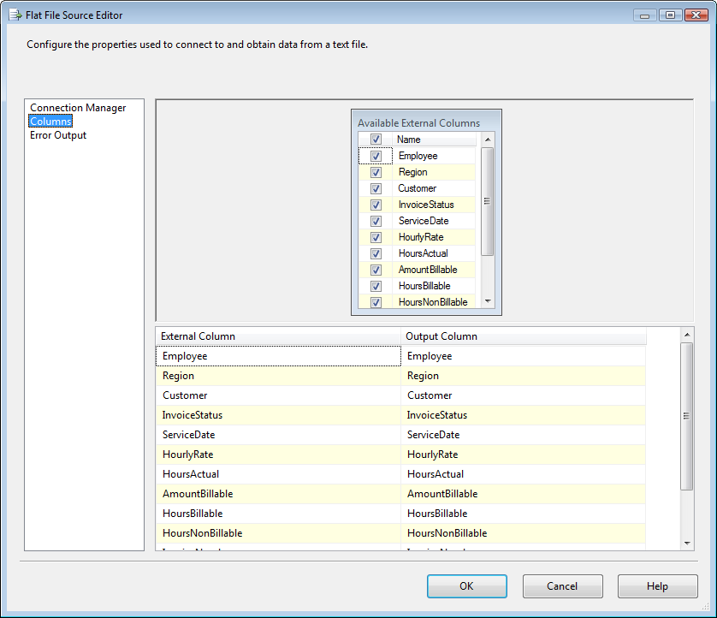
Click OK to exit window.
OLE DB Destination
Double-clicking on the object will open the OLE DB Destination Editor window which already has the properties changed as discussed below:
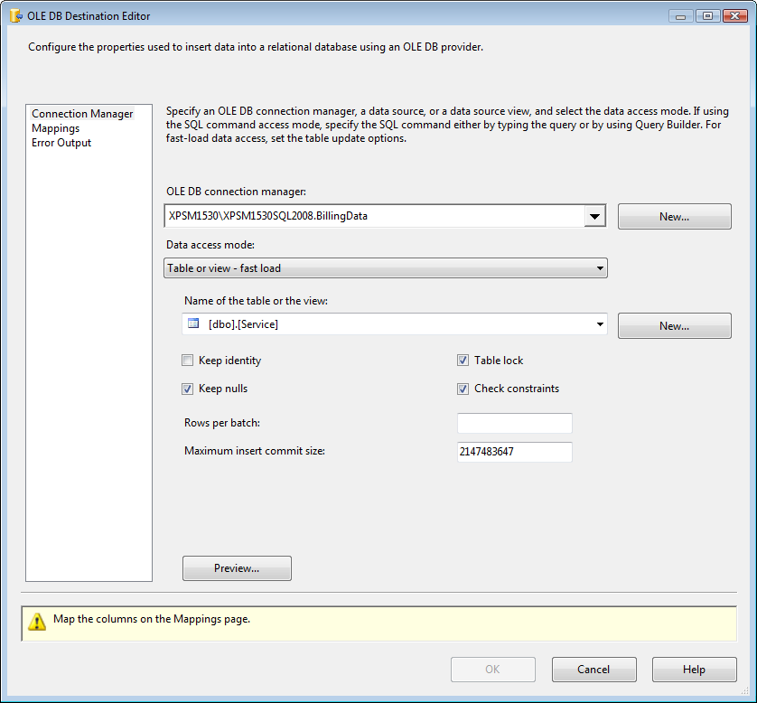
Connection Manager
- Change the “OLE DB connection manager:” to whatever OLE DB Connection Connection you set up in Connections Manager.
The “OLE DB connection manager:” shown above, XPSM1530\XPSM1530SQL2008.BillingData, is my laptop\sqlserverinstance.databasename.
- Select the dbo.Service table from BillingData.
- Click on “Keep nulls” so that check mark appears.
Please note the OK button is grayed out! You need to click on Mappings to complete entering properties for the OLE DB Destination object.
Mappings
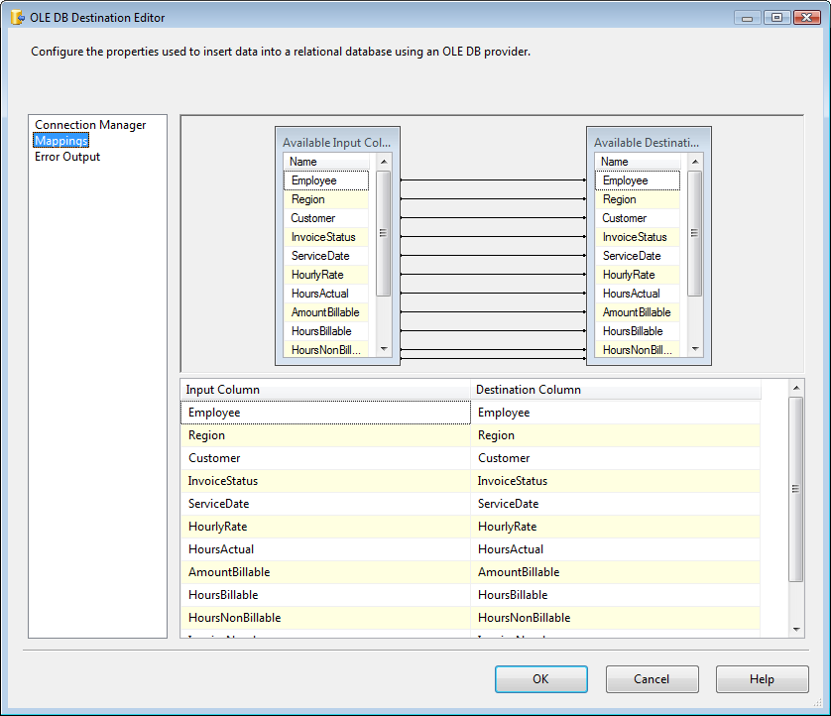
By clicking on Mappings you are setting the Mappings between the columns (fields) shown in your Flat File Source and your OLE DB Destination.
Click OK to close this window.
By now, all the red x marks should have disappeared. However, you are still not done. The last step is to assign the Variable previously setup to the Flat File Connection.
Assign Variable to Flat File Connection
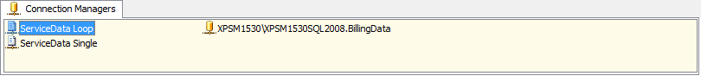
- Click on the “ServiceData Loop” in Connection Managers to show the Properties window.
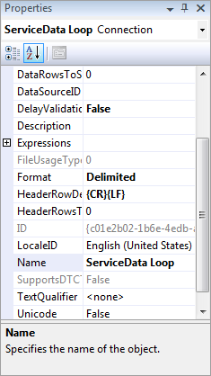
- Click on the plus sign to the left of Expressions and the browse button will appear,
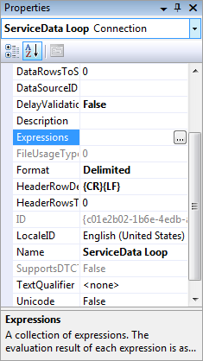
- Click on the browse button to open the Property Expressions Editor,
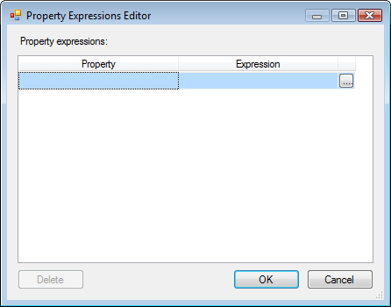
- Click on Property field to get drop-down menu arrow to appear,
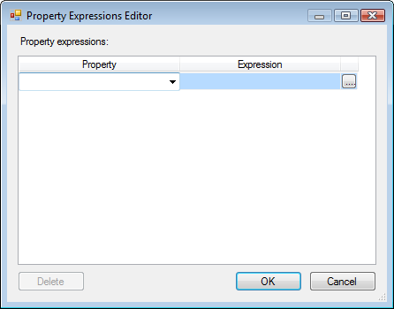
- Click on drop-down menu arrow and select ConnectionString,
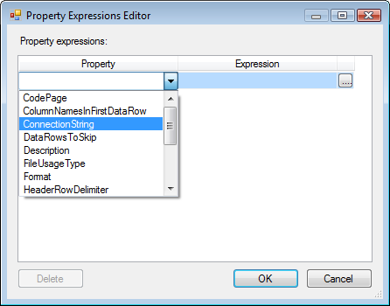
- Click on browse button in Expression field,
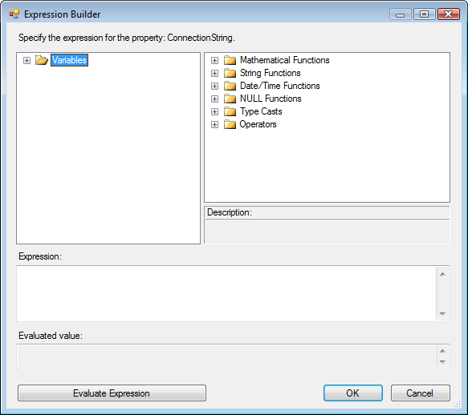
- Double-click on Variables or click on plus sign next to Variables,
- Scroll down and locate the User variable you previously set up and assigned to Variables in the Foreach Loop Container,
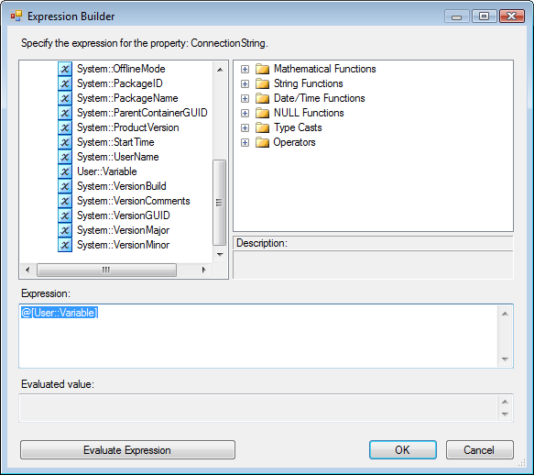
- Drag the variable from the window it is listed in into the Expression: window,
- Click on Evaluate Expression,
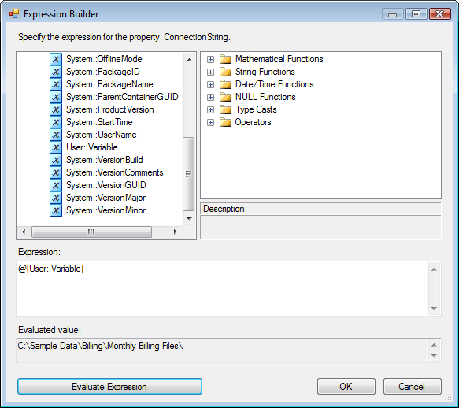
Verify that the path your files you want to loop through is shown in the Evaluated value: window.
- Click OK to close Expression Builder window.
- Click OK again to close Property Expressions Editor window.
At this point you should be able to execute the package and loop through and load the Service table in the BillingData database with the contents of the monthly Service invoice files found in whatever path you placed them and set up above.
Additional Resources
Some additional resources mentioned in the presentation (and above):
- Data Type Mapping for SQL Server and SSIS 2008: Siddharth Mehta’s Blog
- The example mentioned in the presentation is DatePart. In SQL you have the ISO_WEEK option but do not in SSIS.

Back to Table of Contents

